REG. NO: 22TD0053 NAME: MOHAMED B SIRAJUDDEEN YEAR/SEM/SEC: Y2/S4/B

FIBONACCI SERIES

SOURCE CODE:
package fibonacci;
import java.util.Scanner;
public class Fibonacci {
public static void main(String[] args) {
int count,num1=0,num2=1,sum2=1;
System.out.println("how many numbers you want in the sequence");
Scanner Sc=new Scanner(System.in);
count=Sc.nextInt();
Sc.close();
System.out.println("fibonacci series of"+count+"number=");
int i=1;
while(i<=count)
{
System.out.println(num1+"");
int SumofprevTwo =num1+num2;
num1 =num2;
num2 =SumofprevTwo;
i++;
}
}

OUTPUT:

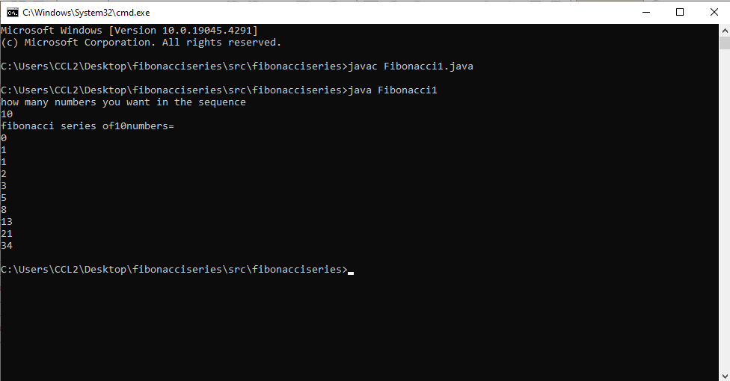

REG. NO: 22TD0053 NAME: MOHAMED B SIRAJUDDEEN YEAR/SEM/SEC: Y2/S4/B

SWITCH CASE

SOURCE CODE:
package switchcase;
import java.util.Scanner;
public class Switchcase {
public static void main(String args[]) {
char c;
int firstnumber,secondnumber,output;
Scanner Sc=new Scanner (System.in);
System.out.println("Enter +for addition,-for subtraction,*for multiplication,/for division:");
c=Sc.next().charAt(0);
System.out.println("enter frist number:");
firstnumber=Sc.nextInt();
System.out.println("Enter the second number;");
secondnumber=Sc.nextInt();
switch(c){
case'+':
output=firstnumber+secondnumber;
case'-':
output=firstnumber-secondnumber;
break;
case'*':
output=firstnumber*secondnumber;
break;
case'/':
output=firstnumber/secondnumber;
break;
default:
System.out.println("please emter the valid symbol!!!:");
return;
}
System.out.printf("%d%s%d=%d",firstnumber,c,secondnumber,output);
}
}

OUTPUT:

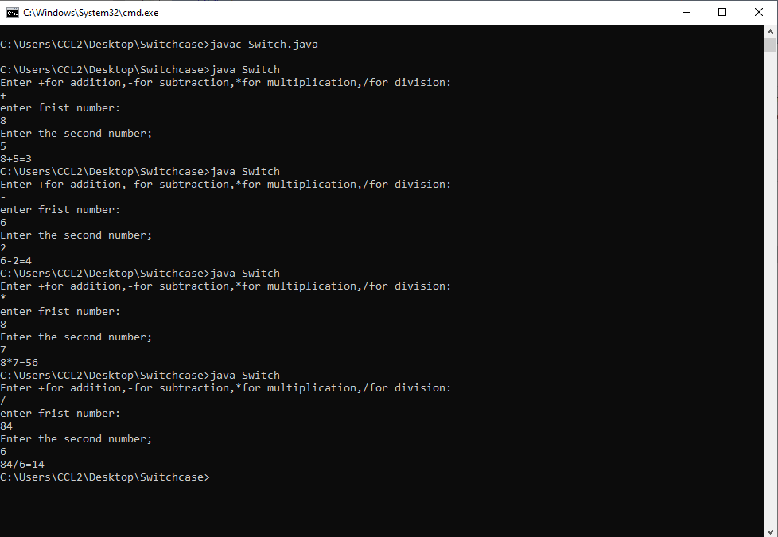

REG. NO: 22TD0053 NAME: MOHAMED B SIRAJUDDEEN YEAR/SEM/SEC: Y2/S4/B

CLASSES AND OBJECTS

SOURCE CODE:
package Classandobjects;
import java.util.Scanner;
public class Classandobjects
{
String name;
float min_bal,amt,w;
long account_no;
void assign()
{
min_bal=1000;
}
void input()
{
Scanner no=new Scanner(System.in);
System.out.println("Enter user name: ");
name=no.nextLine();
Scanner sr=new Scanner(System.in);
System.out.println("Enter the account number");
account_no=sr.nextLong();
System.out.println("Enter the amount you want to deposit: ");
amt=sr.nextFloat();
min_bal=min_bal+amt;
}
void withdraw()
{
System.out.println("Enter the amount you want to withraw: ");
Scanner s1=new Scanner(System.in);
w=s1.nextFloat();
min_bal=min_bal-w;
}
void display()
{
System.out.println("-----------INDIAN BANK------------");
System.out.println("Account holder name: "+name);
System.out.println("Account number: "+account_no);
System.out.println("Account amount: "+min_bal);
}
public static void main(String[] args){
Classandobjects b=new Classandobjects();
b.assign();
b.input();
b.withdraw();
b.display();
}
}

OUTPUT:
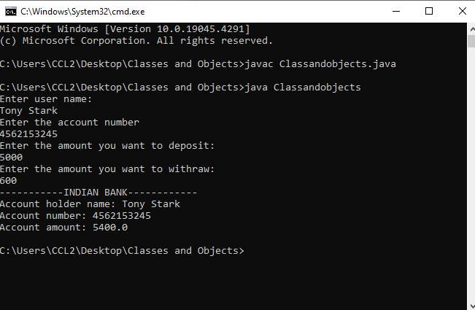

REG. NO: 22TD0053 NAME: MOHAMED B SIRAJUDDEEN YEAR/SEM/SEC: Y2/S4/B

CONSTRUCTOR AND DESTRUCTOR

SOURCE CODE:
package constructor;
import java.util.*;
public class Studentdetails {
public static void main(String[] args)
{
Student stud = new Student();
stud.input();
stud.calc();
stud.display();
stud.finalize();
}
}
class Student
{
int s1,s2,s3,s4,s5,i,avg,tot;
String name;
Scanner s = new Scanner(System.in);
Student()
{
System.out.println("Student Details");
System.out.println("******");
}
public void finalize()
{
System.out.println("Verified");
}
void input()
{
System.out.println("Enter your name:");
name = s.nextLine();
System.out.println("Enter the marks: ");
s1 = s.nextInt();
s2 = s.nextInt();
s3 = s.nextInt();
s4 = s.nextInt();
s5 = s.nextInt();
}
void calc()
{
tot = s1+s2+s3+s4+s5;
avg = tot/5;
}

OUTPUT:
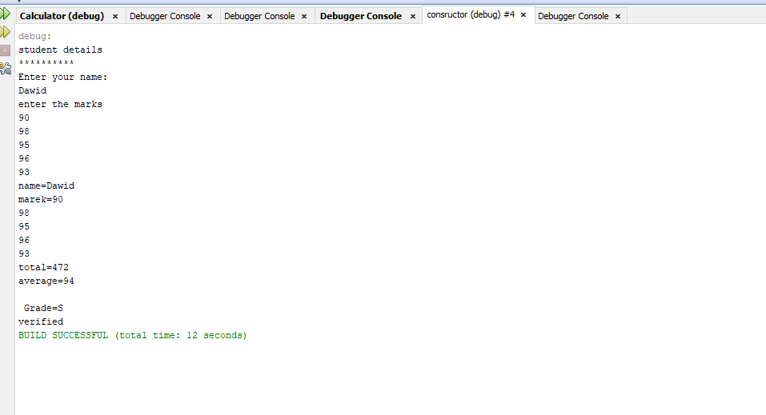

REG. NO: 22TD0053 NAME: MOHAMED B SIRAJUDDEEN YEAR/SEM/SEC: Y2/S4/B

METHOD OVERLOADING

SOURCE CODE:
package methodoverloading;
import java.io.*;
import java.lang.*;
import java.lang.Math;
import java.util.*;
import java.io.IOException;
public class methodoverloading {
public static void main(String[] args) throws IOException
{
shape s = new shape();
int l,b;
int a;
String ss;
BufferedReader brr = new BufferedReader (new InputStreamReader(System.in));
System.out.println("Enter the length (rectangle):");
ss = brr.readLine();
l = Integer.parseInt(ss);
System.out.println("Enter the breadth (rectangle):");
ss = brr.readLine();
b = Integer.parseInt(ss);
System.out.println("Enter the side of a square");
ss = brr.readLine();
a = Integer.parseInt(ss);
s.area(l,b);
s.area(a);
}
}
class shape
{
void area(int l, int b)
{
System.out.println("Area of rectangle");
System.out.println("******");
int c = l*b;
System.out.println(c);
}
void area(int a)
{
System.out.println("Area of square");
System.out.println("******");
int d = a*a;
System.out.println(d);
}
}

OUTPUT:

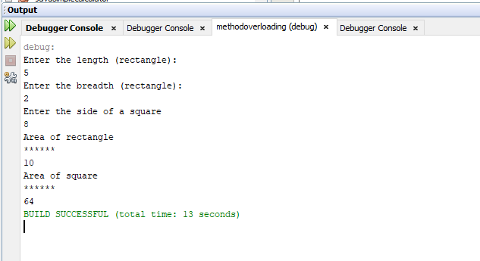

REG. NO: 22TD0053 NAME: MOHAMED B SIRAJUDDEEN YEAR/SEM/SEC: Y2/S4/B

MULTIPLE INHERITANCE

SOURCE CODE:
package multipleinheritance;
interface MotorBike
{
int speed=50;
public void totalDistance();
}
interface Cycle
{
int distance=150;
public void speed();
}
public class Multipleinheritance implements MotorBike,Cycle
{
int totalDistance;
int avgSpeed;
public void totalDistance()
{
totalDistance=speed*distance;
System.out.println("Total Distance Travelled : "+totalDistance);
}
public void speed()
{
int avgSpeed=totalDistance/speed;
System.out.println("Average Speed maintained : "+avgSpeed);
}
public static void main(String args[])
{
Multipleinheritance t1=new Multipleinheritance();
t1.totalDistance();
t1.speed();
}
}

OUTPUT:

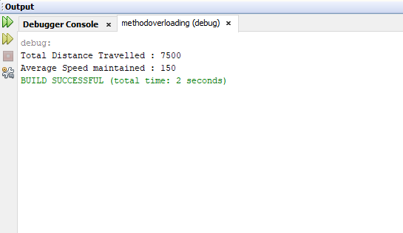

REG. NO: 22TD0053 NAME: MOHAMED B SIRAJUDDEEN YEAR/SEM/SEC: Y2/S4/B

HIERARCHIAL INHERITANCE

SOURCE CODE:
package inheritence;
class product
{
String name;
double price;
public product(String name,double price)
{
this.name=name;
this.price=price;
}
public double Calculatetotalprice(int quantity)
{
return price*quantity;
}
}
class PhysicalProduct extends product
{
public double weight;
public PhysicalProduct(String name,doubleprice,double weight)
{
super(name,price);
this.weight=weight;
}
public double CalculateShippingCost()
{
return weight*0.1;
}}
class DigitalProduct extends product
{
public DigitalProduct(String name,double price)
{
super(name,price);
}}
public class hierarchical
{
public static void main(String args[])
{
PhysicalProductphysicalProduct=new PhysicalProduct("book",15.99,2.5);
DigitalProductdigitalProduct=new DigitalProduct("Ebook",9.99);
System.out.println("Physical Product Invoice:");
System.out.println("Name:"+physicalProduct.name)
System.out.println("Price:"+physicalProduct.price);
System.out.println("Weight:"+physicalProduct.weight+"kg");
System.out.println("Shipping cost:$"+physicalProduct.CalculateShippingCost());
System.out.println("Total price:$"+physicalProduct.Calculatetotalprice(1));
System.out.println("\n Product Invoice");
System.out.println("Name:"+digitalProduct.name);
System.out.println("Price:$"+digitalProduct.price);
System.out.println("Total price:$"+digitalProduct.Calculatetotalprice(1));} }
OUTPUT:

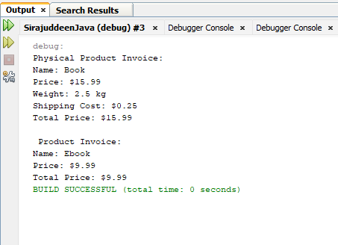

REG. NO: 22TD0053 NAME: MOHAMED B SIRAJUDDEEN YEAR/SEM/SEC: Y2/S4/B

EXCEPTION HANDLING

SOURCE CODE:
package exception;
import java.io.*;
import java.io.IOException;
public class Exception{

public static void main(String[] args)throws IOException
{
int ch;
BufferedReader br=new BufferedReader
(new InputStreamReader(System.in));
System.out.println("1.arithmeticException 2.NumberFormatException 3.ArrayIndexOutOfBoundException 4.StringIndexOutOfBoundException");
System.out.println("Enter yoour choice");
ch=Integer.parseInt(br.readLine());
switch(ch)
{
case 1:
try{
int a=30,b=0;
int c=a/b;
System.out.println("Result="+c);
}
catch(ArithmeticException e)
{
System.out.println("Exception Handling");
System.out.println("-----------");
System.out.println("can't divide a number by 0");
}
break;
case 2:
try{
int num=Integer.parseInt("akki");
System.out.println(num);
}
catch(NumberFormatException e)
{
System.out.println("Exception Handling");
System.out.println("--------");
System.out.println("Number format exception");
}
break;
case 3:
try{
int a[]=new int[5];
a[6]=9;
}
catch(ArrayIndexOutOfBoundsException e)
{
System.out.println("exception Hnadling");
System.out.println("--------");
System.out.println("Array Index is Out of bounds");
}
break;
case 4:
try
{
String a="this is like chipping";
char c=a.charAt(24);
System.out.println(c);
}
catch(StringIndexOutOfBoundsException e)
{
System.out.println("exception handling");
System.out.println("-------");
System.out.println("StringIndexOutOfBoundsException");
}
break;
default:
System.out.println("INVALID");
break;
}

}
}

OUTPUT:

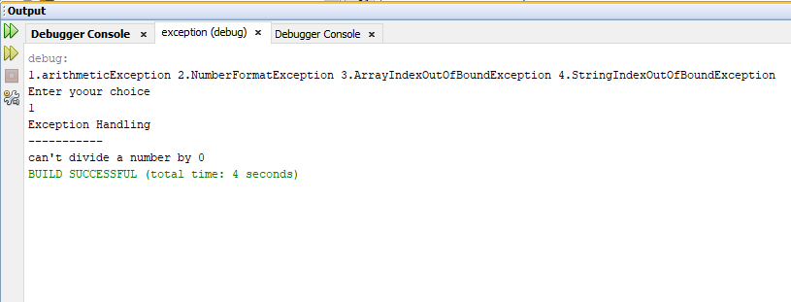

REG. NO: 22TD0053 NAME: MOHAMED B SIRAJUDDEEN YEAR/SEM/SEC: Y2/S4/B

METHOD OVERLOADING

SOURCE CODE:

package methodoverloading;
import java.io.*;
import java.lang.*;
import java.lang.Math;
import java.util.*;
import java.io.IOException;
public class overloading
{
public static void main(String[] args)throws IOException
{
shape s=new shape();
int l,b;
int a;
String ss;
BufferedReader brr=new BufferedReader(new InputStreamReader(System.in));
System.out.println("enter the value");
ss=brr.readLine();
l=Integer.parseInt(ss);
System.out.println("enter the value");
ss=brr.readLine();
b=Integer.parseInt(ss);
System.out.println("enter a value");
ss=brr.readLine();
a=Integer.parseInt(ss);
s.area(l,b);
s.area(a);
}

}
class shape
{
void area(int l,int b)
{
System.out.println("area of rectangle");
System.out.println("##############");
int c=l*b;
System.out.println(c);
}
void area(int a)
{
System.out.println("Area of square");
System.out.println("$$$$$$$$$$$$$$$$$$$");
int d= a*a;
System.out.println(d);
}
}

OUTPUT:

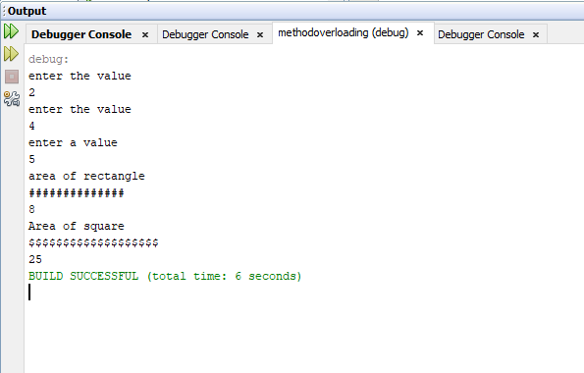

REG. NO: 22TD0053 NAME: MOHAMED B SIRAJUDDEEN YEAR/SEM/SEC: Y2/S4/B

FILES AND STREAMS

SOURCE CODE:
package filesandstream;
import java.io.File;
import java.io.FileWriter;

import java.io.IOException;
public class Filesandstream
{
public static void main(String[] args)
{
File file = new File("intro.txt");
boolean result;
try
{
result = file.createNewFile();
if(result)
{
System.out.println("file created");

}
else
{
System.out.println("File already exists");
}
FileWriter myWriter = new FileWriter("intro.txt");
myWriter.write("Hi my name is Robot");
myWriter.close();
}
catch (IOException e)
{
e.printStackTrace();
}
}
}

OUTPUT:

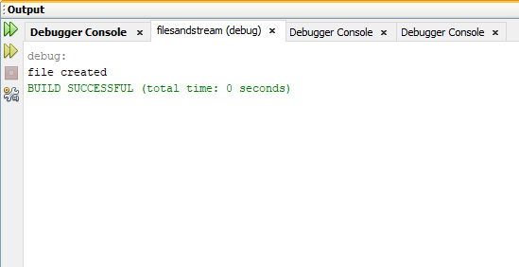
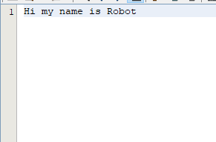

REG. NO: 22TD0053 NAME: MOHAMED B SIRAJUDDEEN YEAR/SEM/SEC: Y2/S4/B

PACKAGES

SOURCE CODE:

Mainpack.java:

package mypack;
import java.io.*;
import java.io.IOException;

public class MainPack {
public static void main(String args[]) throws IOException
{
Package1 a = new Package1();
Package2 b = new Package2();
Package3 c = new Package3();
DataInputStream obj = new DataInputStream(System.in);
while(true)
{
System.out.println("Choose an option");
System.out.println("\n\t1. Sum of N numbers");
System.out.println("\n\t2. Print Odd Number");
System.out.println("\n\t3. Print Even Number");

String choice1 = obj.readLine();
int choice = Integer.parseInt(choice1);
switch(choice)
{
case 1:
a.sumofNnumbers();
break;
case 2:
b.oddNumbers();
break;
case 3:
c.evenNumbers();
break;
case 4:
System.exit(1);
break;
}
}
}
}

Package1.java:
// SUM OF N NUMBERS

package mypack;
import java.io.*;
import java.util.Scanner;
public class Package1 {
public void sumofNnumbers()
{
int n, i=0, s=0;
System.out.println("Enter value: ");
Scanner sr = new Scanner(System.in);
n = sr.nextInt();
while(i<n)
{
i=i+1;
System.out.println(i);
s = s+i;
}
System.out.println(s);
}
}

Package2.java:

// ODD NUMBER
package mypack;
import java.io.*;
import java.util.Scanner;
public class Package2 {
public void oddNumbers()
{
int n, i=1;
System.out.println("Enter n value: ");
Scanner sr = new Scanner(System.in);
n = sr.nextInt();
while(i<n)
{
i = i+2;
System.out.println(i);
}
}
}

Package3.java:

// EVEN NUMBER
package mypack;
import java.io.*;
import java.util.Scanner;
public class Package3 {
public void evenNumbers()
{
int n, i=0;
System.out.println("Enter n value: ");
Scanner sr = new Scanner(System.in);
n = sr.nextInt();
while(i<n)
{
i = i+2;
System.out.println(i);
}
}
}

OUTPUT:

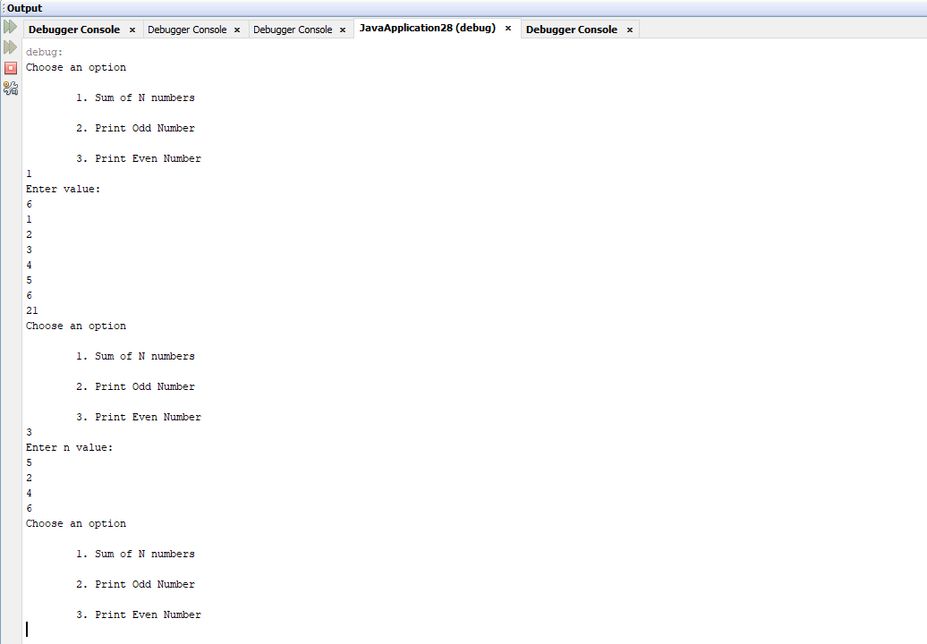

REG. NO: 22TD0053 NAME: MOHAMED B SIRAJUDDEEN YEAR/SEM/SEC: Y2/S4/B

MULTITHREADING

SOURCE CODE:
package Javaprogram;
import java.lang.Thread;
class A extends Thread
{
public void run()
{
for (int i=1;i<=5;i++)
{
System.out.println("From thread A i="+i);
}
System.out.println("Exit A");;
}
}
class B extends Thread
{
public void run()
{
for(int j=1;j<=5;j++)
{
System.out.println("From thread B j="+j);
}
System.out.println("Exit B");
}
}
class C extends Thread
{
public void run()
{
for(int k=1;k<=5;k++)
{
System.out.println("From thread C k="+k);
}
System.out.println("Exit C");
}
}
class Threadtest
{
public static void main(String[] args)
{
new A().start();
new B().start();
new C().start();
}
}

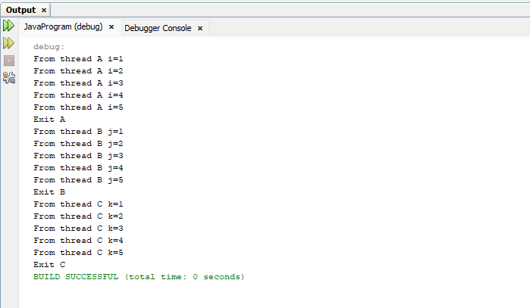
OUTPUT:

REG. NO: 22TD0053 NAME: MOHAMED B SIRAJUDDEEN YEAR/SEM/SEC: Y2/S4/B

SOCKET

SOURCE CODE:
serverside.java:
package JavaApplication24;
import java.net.*;
public class serverside
{
public static void main(String[]args)
{
try
{
int port=Integer.parseInt("4444");
DatagramSocket ds=new DatagramSocket(port);
byte buffer[]=new byte[20];
while(true)
{
DatagramPacket dp=new DatagramPacket(buffer,buffer.length);
ds.receive(dp);
String str=new String(dp.getData());
System.out.println(str);
}
}
catch(Exception e)
{
e.printStackTrace();
}
}
}

clientside.java:
package sockets;
import java.net.*;
class clientside
{
public static void main(String[]args)
{
try
{
InetAddress ia=InetAddress.getByName("192.168.5.122");
int port=Integer.parseInt("4444");
DatagramSocket ds=new DatagramSocket();
String s1="Hello";
byte buffer[]=s1.getBytes();
DatagramPacket dp=new DatagramPacket(buffer,buffer.length,ia,port);
ds.send(dp);

}
catch(Exception e)
{
System.out.println("Exception:"+e);
}
}
}
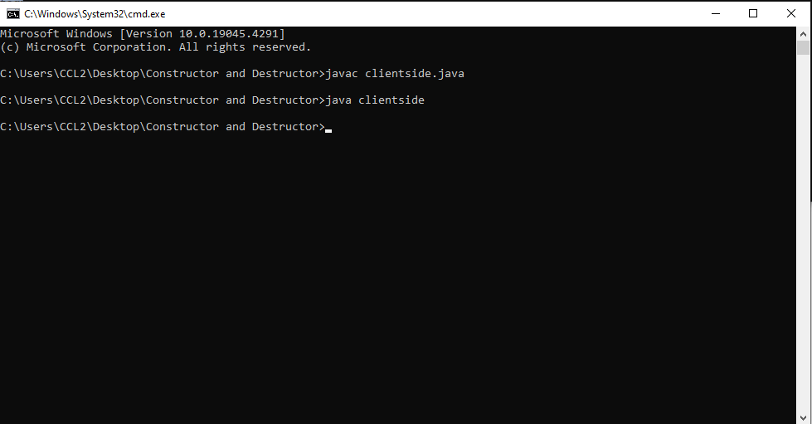
OUTPUT:

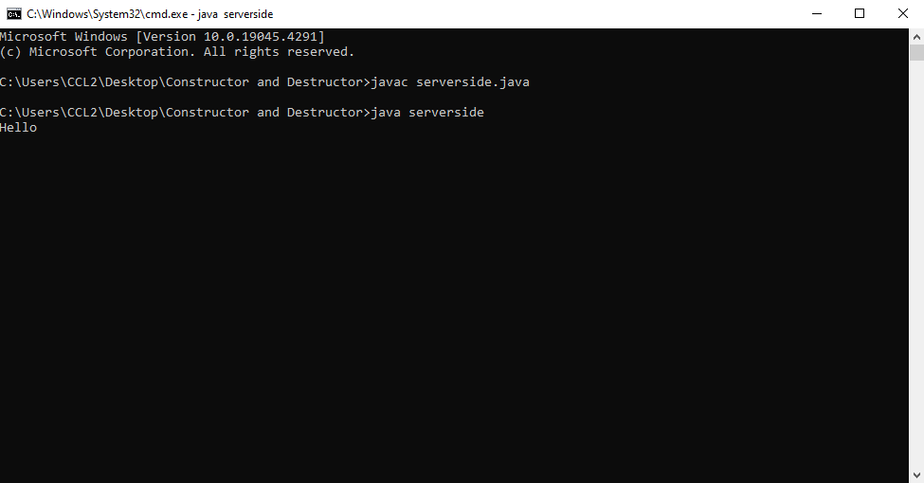

REG. NO: 22TD0053 NAME: MOHAMED B SIRAJUDDEEN YEAR/SEM/SEC: Y2/S4/B

ABSTRACT CLASS

SOURCE CODE:

import java.util.*;

abstract class Alpha{

int a,b;

void getdata()

{

Scanner scn=new Scanner(System.in);

System.out.println("Enter A value is:");

a=scn.nextInt();

System.out.println("Enter B value is:");

b=scn.nextInt();

}

abstract void display();

}

public class Abstr extends Alpha{

int add, sub,mul;

void display()

{

add=a+b;

sub=a-b;

mul=a*b; System.out.println("Addition value is:" +add);

System.out.println("Subtracted value is:" +sub);

System.out.println("Multiplied value is:" +mul);

}

public static void main(String[] args)

{

Abstr obj=new Abstr();

obj.getdata();

obj.display();

}
}

OUTPUT:

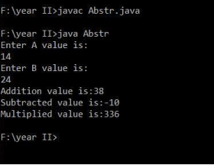

REG. NO: 22TD0053 NAME: MOHAMED B SIRAJUDDEEN YEAR/SEM/SEC: Y2/S4/B

REMOTE METHOD INVOCATION

SOURCE CODE:

RMI INTERFACE:
import java.rmi.*;
public interface AddServerInterface extends Remote
{double add(double d1,double d2)throws RemoteException;
}

RMI IMPLEMENTING CLASS:
import java.rmi.*;
import java.rmi.server.*;
public class AddServerImplementingClass extends UnicastRemoteObject
implements AddServerInterface{
public AddServerImplementingClass()throws RemoteException{
}
public double add(double d1,double d2)throws RemoteException{
return d1+d2;
}
}

RMI SERVER SIDE:
import java.net.*;
import java.rmi.*;
public class AddServer
{
public static void main(String[] args)throws RemoteException
{
try {
AddServerImplementingClass obj=new AddServerImplementingClass();
Naming.rebind("AddServer",obj);
}
catch(Exception e)
{
System.out.println("Exception"+e);
}
}
}

RMI CLIENT SIDE:
import java.rmi.*;
public class AddClient{
public static void main(String[] args){
try {
String addServerURL="rmi://"+args[0]+"/AddServer";
AddServerInterface
obj=(AddServerInterface)Naming.lookup(addServerURL);
System.out.println("the first number is="+args[1]);
double d1=Double.parseDouble(args[1]);
System.out.println("the second number is="+args[2]);
double d2=Double.parseDouble(args[2]);
System.out.println("the sum is"+obj.add(d1,d2));
}
catch(Exception e)
{
System.out.println("Exception="+e);
}
}
}

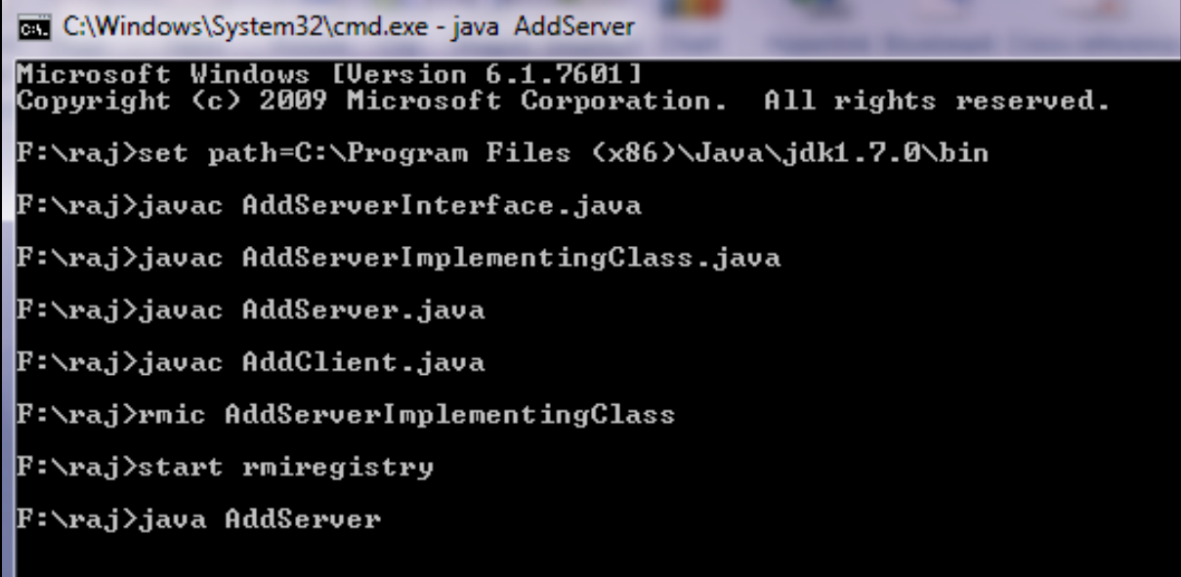
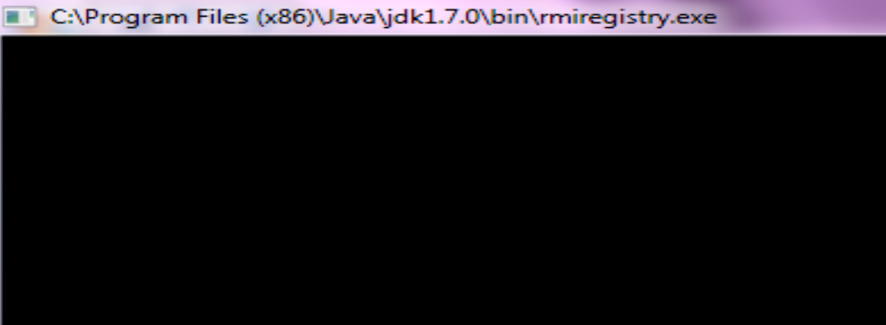
OUTPUT:
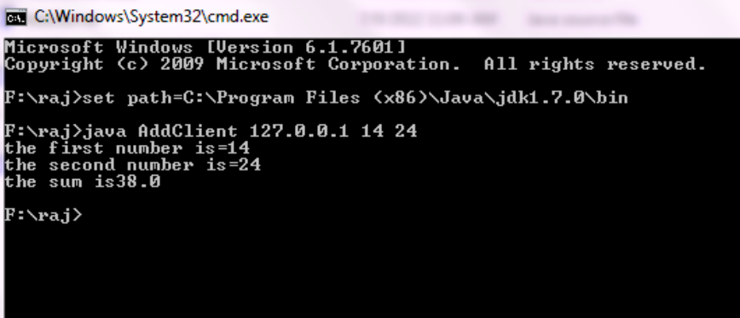
REG. NO: 22TD0053 NAME: MOHAMED B SIRAJUDDEEN YEAR/SEM/SEC: Y2/S4/B

APPLET

SOURCE CODE:
package applet;
import java.awt.*;
import java.awt.event.*;
import java.applet.*;
import java.awt.color.*;
public class signal extends Applet implements ActionListener
{
int colorNum;
Button bttn1=new Button ("stop traffic");
Button bttn2=new Button ("caution");
Button bttn3=new Button ("proceed");
// Button bttn4=new Button ("stop traffic");
// Button bttn5=new Button ("caution");
// Button bttn6=new Button ("proceed");
public void init()
{
setBackground(Color.LIGHT_GRAY);
bttn1.addActionListener(this);
bttn2.addActionListener(this);
bttn3.addActionListener(this);
add(bttn1);
add(bttn2);
add(bttn3);

}
public void paint(Graphics g)
{
g.setColor(Color.BLACK);
g.setColor(colorNum==1?Color.red:Color.red.darker().darker());
g.fillOval(30,40,20,20);
g.setColor(colorNum==2?Color.yellow:Color.yellow.darker().darker());
g.fillOval(30,70,20,20);
g.setColor(colorNum==3?Color.green:Color.green.darker().darker());
g.fillOval(30,100,20,20);

}
public void actionPerformed(ActionEvent evt)
{
if(evt.getSource()==bttn1)
colorNum=1;
else if(evt.getSource()==bttn2)
colorNum=2;
else
colorNum=3;
repaint();
}
}

OUTPUT:

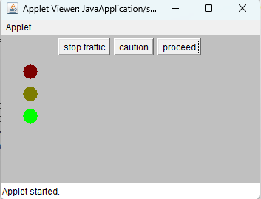

REG. NO: 22TD0053 NAME: MOHAMED B SIRAJUDDEEN YEAR/SEM/SEC: Y2/S4/B

SWING

SOURCE CODE:
package swinglogin;
import java.awt.event.ActionEvent;
import java.awt.event.ActionListener;
import javax.swing.JButton;
import javax.swing.JFrame;
import javax.swing.JLabel;
import javax.swing.JPasswordField;
import javax.swing.JTextField;
import java.awt.*;
import java.awt.event.*;
import javax.swing.*;

public class Swinglogin {
public static void main(String[] args)
{
JFrame frame=new JFrame("Login Screen"); //Line 1
JLabel label = new JLabel();//Line 2
final JLabel tf= new JLabel();

label.setBounds(20,150, 200,50);
//Line 3
final JPasswordField value = new JPasswordField();//Line 4
value.setBounds(100,75,100,30);
JLabel userNameLabel=new JLabel("User Name:");//Line 5
userNameLabel.setBounds(20,20, 80,30);
JLabel paswordLabel=new JLabel("Password:");//Line 6
paswordLabel.setBounds(20,75, 80,30);
JButton loginButton = new JButton("Login Here");//Line 7
loginButton.setBounds(100,120, 80,30);
final JTextField text = new JTextField();//Line 8
text.setBounds(100,20, 100,30);
tf.setBounds(200,120,500,130);
frame.add(value); //Line 9
frame.add(userNameLabel);
frame.add(label); //Line 9
frame.add(paswordLabel); //Line 9
frame.add(loginButton); //Line 9
frame.add(text);
frame.add(tf);//Line 9
frame.setSize(400,400);
frame.setLayout(null); //Line 10
frame.setVisible(true); //Line
loginButton.addActionListener(new ActionListener() {
public void actionPerformed(ActionEvent e) {
String userNameDisplay;
userNameDisplay = text.getText()+" Login are Created";
tf.setText(userNameDisplay);
//System.out.println(userNameDisplay);
}
});

}}
OUTPUT:

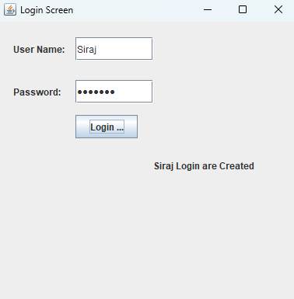

REG. NO: 22TD0053 NAME: MOHAMED B SIRAJUDDEEN YEAR/SEM/SEC: Y2/S4/B

CALCULATOR
SOURCE CODE:
package Calculator;
import java.awt.event.*;
import javax.swing.*;
import java.awt.*;
class Calculator extends JFrame implements ActionListener
{
static JFrame f;
static JTextField l;
String s0, s1, s2;
Calculator()
{
s0 = s1 = s2 = " ";
}
public static void main(String args[])
{
f = new JFrame("Calculator");
try
{
UIManager.setLookAndFeel(UIManager.getSystemLookAndFeelClassName());
}
catch (Exception e)
{
System.err.println(e.getMessage());
}
Calculator C = new Calculator();
l = new JTextField(16);
l.setEditable(false);
JButton b0, b1, b2, b3, b4, b5, b6, b7, b8, b9, ba, bs, bd, bm, be, beq, beq1;
b0 = new JButton("0");
b1 = new JButton("1");
b2 = new JButton("2");
b3 = new JButton("3");
b4 = new JButton("4");
b5 = new JButton("5");
b6 = new JButton("6");
b7 = new JButton("7");
b8 = new JButton("8");
b9 = new JButton("9");
beq1 = new JButton("=");
ba = new JButton("+");
bs = new JButton("-");
bd = new JButton("/");
bm = new JButton("*");
beq = new JButton("C");
be = new JButton(".");
JPanel p = new JPanel();
bm.addActionListener(C);
bd.addActionListener(C);
bs.addActionListener(C);
ba.addActionListener(C);
b9.addActionListener(C);
b8.addActionListener(C);
b7.addActionListener(C);
b6.addActionListener(C);
b5.addActionListener(C);
b4.addActionListener(C);
b3.addActionListener(C);
b2.addActionListener(C);
b1.addActionListener(C);
b0.addActionListener(C);
be.addActionListener(C);
beq.addActionListener(C);
beq1.addActionListener(C);
p.add(l);
p.add(ba);
p.add(b1);
p.add(b2);
p.add(b3);
p.add(bs);
p.add(b4);
p.add(b5);
p.add(b6);
p.add(bm);
p.add(b7);
p.add(b8);
p.add(b9);
p.add(bd);
p.add(be);
p.add(b0);
p.add(beq);
p.add(beq1);
p.setBackground(Color.blue);
f.add(p);
f.setSize(200, 220);
f.show();
}
public void actionPerformed(ActionEvent e)
{
String s = e.getActionCommand();
if ((s.charAt(0) >= '0' && s.charAt(0) <= '9') || s.charAt(0) == '.')
{
if (!s1.equals(""))
s2 = s2 + s;
else
s0 = s0 + s;
l.setText(s0 + s1 + s2);
}
else if (s.charAt(0) == 'C')
{
s0 = s1 = s2 = "";
l.setText(s0 + s1 + s2);
}
else if (s.charAt(0) == '=')
{
double te;
if (s1.equals("+"))
te = (Double.parseDouble(s0) + Double.parseDouble(s2));
else if (s1.equals("-"))
te = (Double.parseDouble(s0) - Double.parseDouble(s2));
else if (s1.equals("/"))
te = (Double.parseDouble(s0) / Double.parseDouble(s2));
else
te = (Double.parseDouble(s0) * Double.parseDouble(s2));
l.setText(s0 + s1 + s2 + "=" + te);
s0 = Double.toString(te);
s1 = s2 = "";}
else {
if (s1.equals("") || s2.equals(""))
s1 = s;
else {
double te;
if (s1.equals("+"))
te = (Double.parseDouble(s0) + Double.parseDouble(s2));
else if (s1.equals("-"))
te = (Double.parseDouble(s0) - Double.parseDouble(s2));
else if (s1.equals("/"))
te = (Double.parseDouble(s0) / Double.parseDouble(s2));
te = (Double.parseDouble(s0) * Double.parseDouble(s2));
s0 = Double.toString(te);
s1 = s;
s2 = "";
}
l.setText(s0 + s1 + s2);
}
} }
OUTPUT:

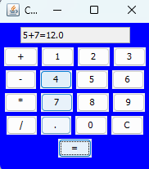

REG. NO: 22TD0053 NAME: MOHAMED B SIRAJUDDEEN YEAR/SEM/SEC: Y2/S4/B

JDBC
SOURCE CODE:
package jdbcempdetails;
import java.sql.Connection;
import java.sql.DriverManager;
import java.sql.ResultSet;
import java.sql.Statement;
public class JDBCEmpDetails
{
public static void main(String args[])
{
try
{
Class.forName("net.ucanaccess.jdbc.UcanaccessDriver");
Connection con = DriverManager.getConnection("jdbc:ucanaccess://empdetail.accdb");
System.out.println(con);
Statement s = con.createStatement();
String query = "select * from Employee";
s.execute(query);
ResultSet rs = s.getResultSet();
while(rs.next())
{
System.out.println("Serial number:"
+rs.getString(1));
System.out.println("Name:"+rs.getString(2));
System.out.println("Salary:"
+rs.getString(3));

}
s.close();
con.close();

}
catch(Exception e)
{
System.out.println("exception"+e);
}
}
}

OUTPUT:

